1. Docker Architecture:
Docker follows a client-server architecture, which includes the following components:
- Docker Client:
The interface through which users interact with Docker (e.g., CLI commands like docker run, docker build).
- Docker Daemon (dockerd):
The server running in the background that manages Docker objects like images, containers, networks, and volumes.
- Docker Images:
Read-only templates used to create containers. Each image is built from a Dockerfile.
- Docker Containers:
Running instances of Docker images that package the application and its dependencies.
- Docker Registry:
A repository (like Docker Hub) that stores Docker images.
Users can pull images from and push images to the registry.
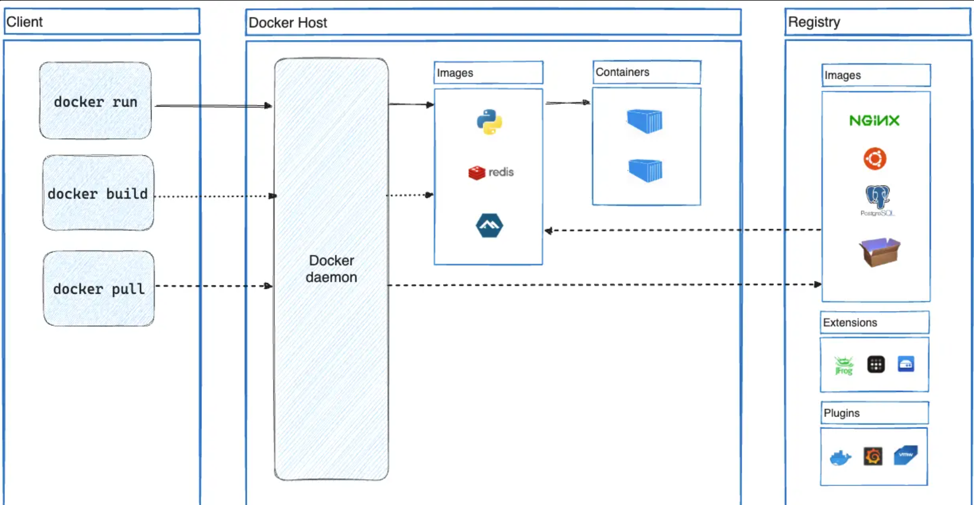

2. Installation Steps
# Update packages
sudo apt update

# Install Docker
sudo apt install docker.io -y

# Start and enable Docker service
sudo systemctl start docker
sudo systemctl enable docker

# Verify installation
docker –version

3. Docker Commands to Manage Images and Containers:
# Pull an image from Docker Hub
docker pull ubuntu

# List available images
docker images

# Remove an image
docker rmi <image_id>

Docker Container Life Cycle:
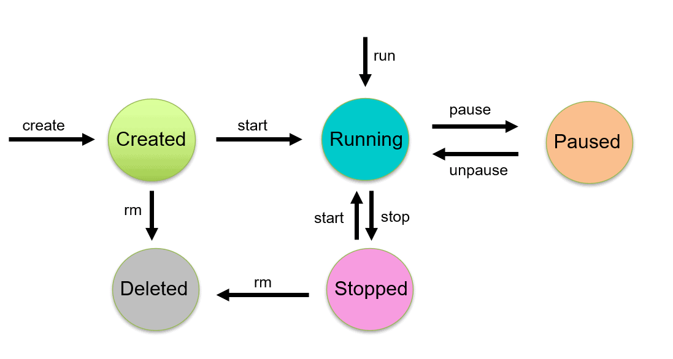

EXPERIMENT-7
eval $(minikube docker-env -u) if you did 8 and then again want to do 7

mkdir k8s-demo-app
cd k8s-demo-app

vim app.js
const express = require("express");
const app = express();
const port = 3000;

app.get("/", (req, res) => {
res.send("Hello from Kubernetes App!");
});

app.listen(port, () => {
console.log(App running on port ${port});
});

Vim package.json
{
"name": "k8s-demo-app",
"version": "1.0.0",
"main": "app.js",
"scripts": {
"start": "node app.js"
},
"dependencies": {
"express": "^4.18.2"
}
}

Vim dockerfile
FROM node:18-alpine
WORKDIR /app
COPY package*.json ./
RUN npm install
COPY . .
EXPOSE 3000
CMD ["npm", "start"]

docker build -t k8s-demo-app:v1 --no-cache .
docker run -p 3000:3000 k8:v1
docker login

8th
cd ~/flask-app
vim app.py
from flask import Flask
app = Flask(__name__)

@app.route('/')
def home():
return "Hello from Flask App running on Kubernetes! 🚀"

if __name__ == '__main__':
app.run(host='0.0.0.0', port=5000)

vim requirements.txt
Flask==2.2.5
Vim dockerfile
FROM python:3.9-slim

WORKDIR /app
COPY . .

RUN pip install -r requirements.txt

EXPOSE 5000
CMD ["python", "app.py"]

minikube start

eval $(minikube docker-env)

docker build -t flask-k8s-app:1.0 .

vim deployment.yaml
apiVersion: apps/v1
kind: Deployment
metadata:
name: flask-deployment
spec:
replicas: 2
selector:
matchLabels:
app: flask-app
template:
metadata:
labels:
app: flask-app
spec:
containers:
- name: flask-app
image: flask-k8s-app:1.0 # Local image in Minikube
imagePullPolicy: Never # <--- This line is REQUIRED for local images
ports:
- containerPort: 5000

Vim service.yaml
apiVersion: v1
kind: Service
metadata:
name: flask-service
spec:
type: NodePort
selector:
app: flask-app
ports:
- protocol: TCP
port: 5000
targetPort: 5000
nodePort: 31001

kubectl apply -f deployment.yaml
kubectl apply -f service.yaml

kubectl get pods

minikube service flask-service

9 EXPERIMENT

wget https://apt.puppet.com/puppet-release-bionic.deb
sudo dpkg -i puppet-release-bionic.deb
sudo apt update
sudo apt install puppetserver -y
sudo systemctl start puppetserver
sudo systemctl enable puppetserver
sudo nano /etc/puppetlabs/puppet/puppet.conf
put the below on in it
[agent]
server = daivik
environment = production
runinterval = 30m

ctrl+x , Y, enter

# Start Puppet Server
sudo systemctl start puppetserver
sudo systemctl enable puppetserver

# Start Puppet Agent
sudo systemctl start puppet
sudo systemctl enable puppet

sudo /opt/puppetlabs/bin/puppet agent --test

10
puppet –version
mkdir -p ~/puppet-demo/modules/webserver/{manifests,lib/puppet/functions/webserver}
nano ~/puppet-demo/modules/webserver/manifests/init.pp
class webserver {
package { 'apache2':
ensure => installed,
}

service { 'apache2':
ensure => running,
enable => true,
}

file { '/var/www/html/index.html':
ensure => file,
content => "<h1>Hello from Puppet Webserver!</h1>",
}

# Call custom function (Puppet 8)
$message = webserver::greet()
notify { $message: }
}

nano ~/puppet-demo/modules/webserver/lib/puppet/functions/webserver/greet.rb
Puppet::Functions.create_function(:'webserver::greet') do
def greet()
"Webserver setup done!"
end
end

nano ~/puppet-demo/site.pp
include webserver

sudo /opt/puppetlabs/bin/puppet apply /home/daivik/puppet-demo/site.pp --modulepath=/home/daivik/puppet-demo/modules --debug

